**Assignment MT1-2021-1**

**Section =1**

(Based on the work out problems in the text book)

1. From book: Principle of mass transfer by B.K. Dutta Ex.2.1 Page no.10

**Ex.2.2 Page no.16**

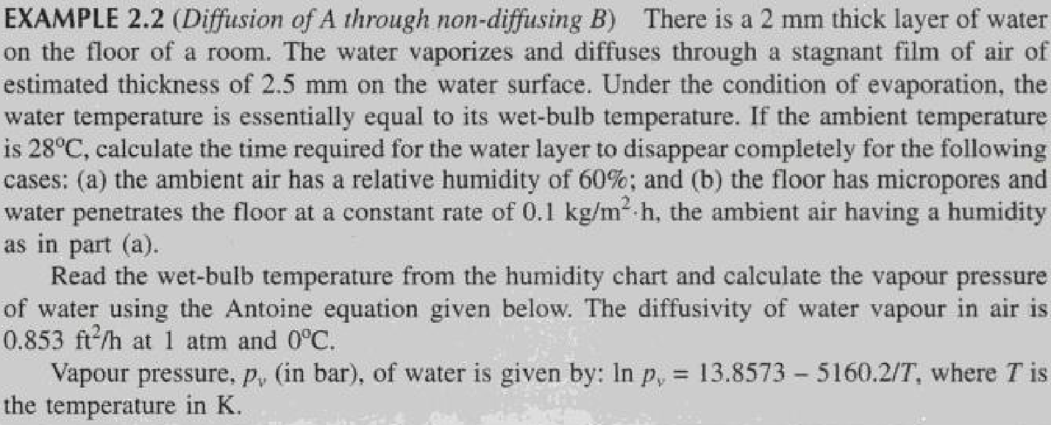

**Ex.2.3 page no.18**

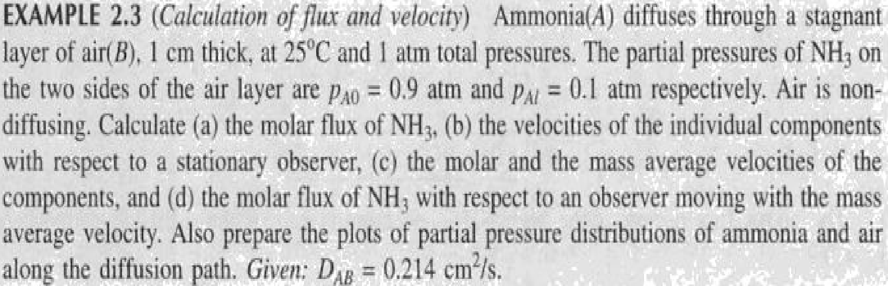

**Ex.2.4 page no .21**

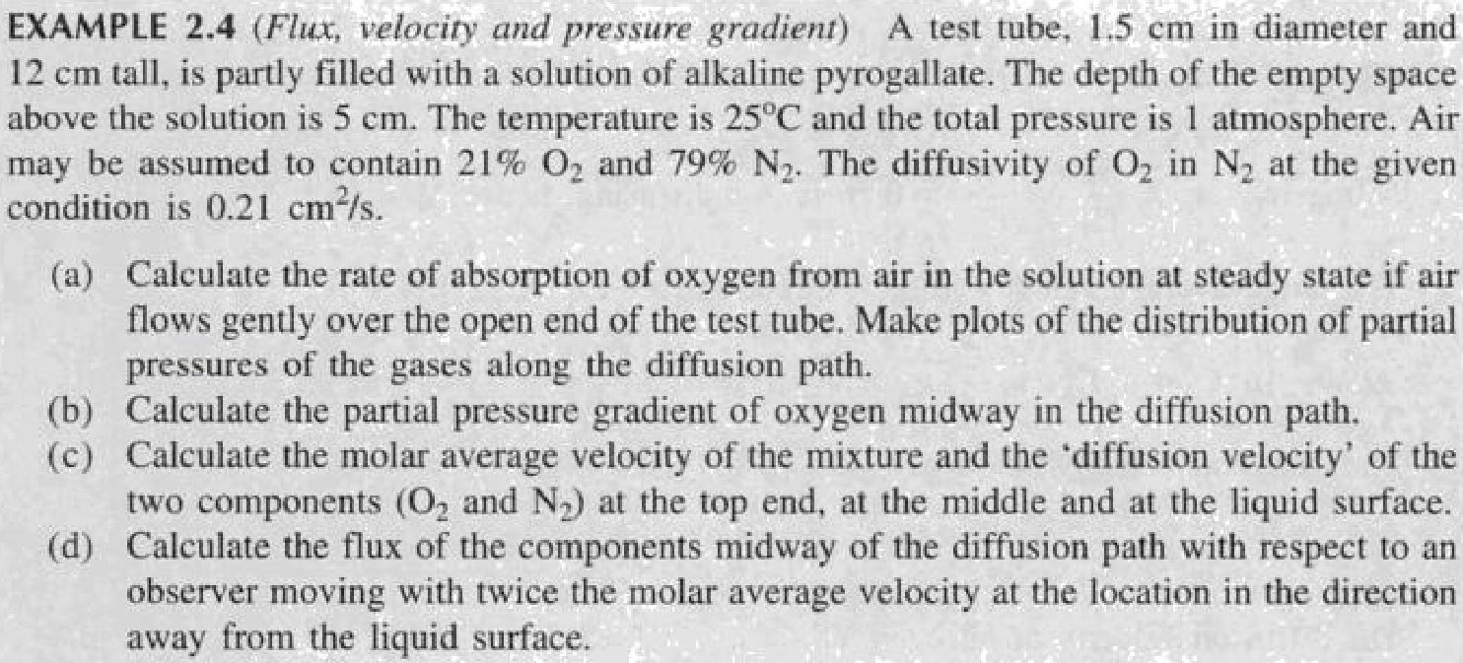

**Ex.2.6 page no.24**

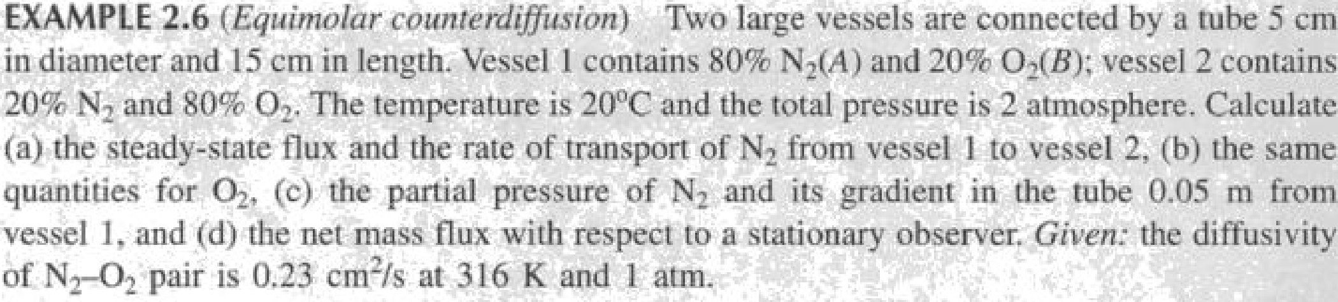

**Ex.2.7 Page no .25**

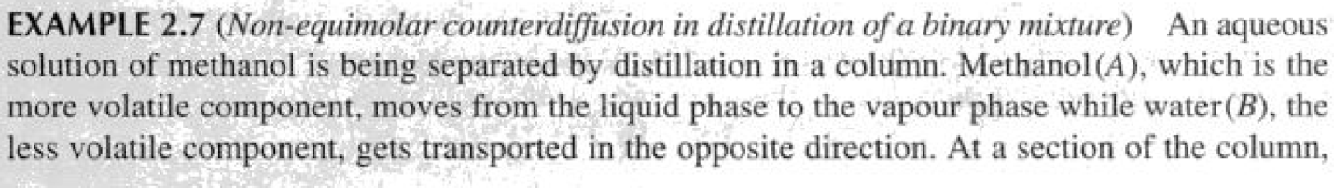

**Ex.2.19 page no 58**



Ex.2.18 Page no.56

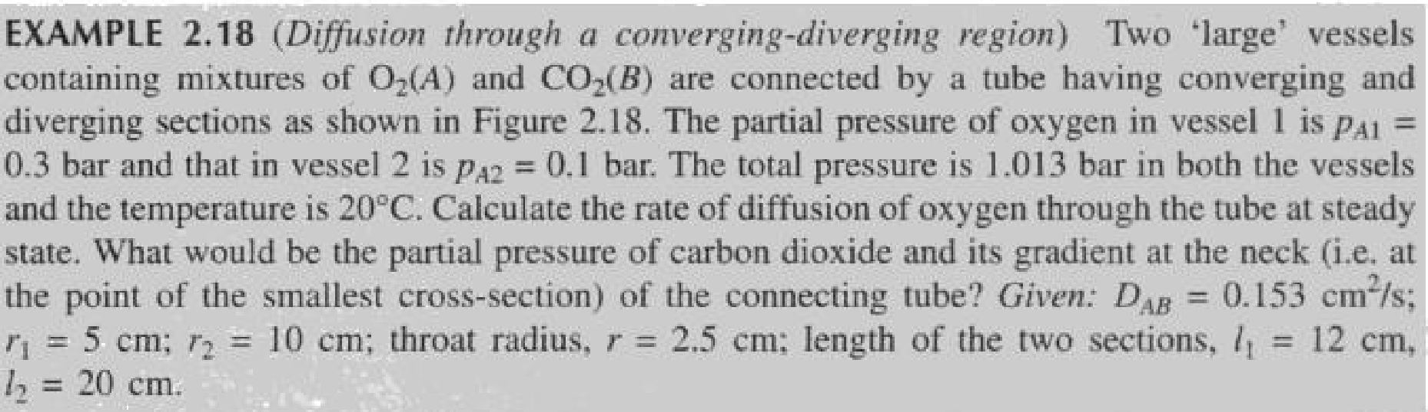

Ex.2.17 Page no.55

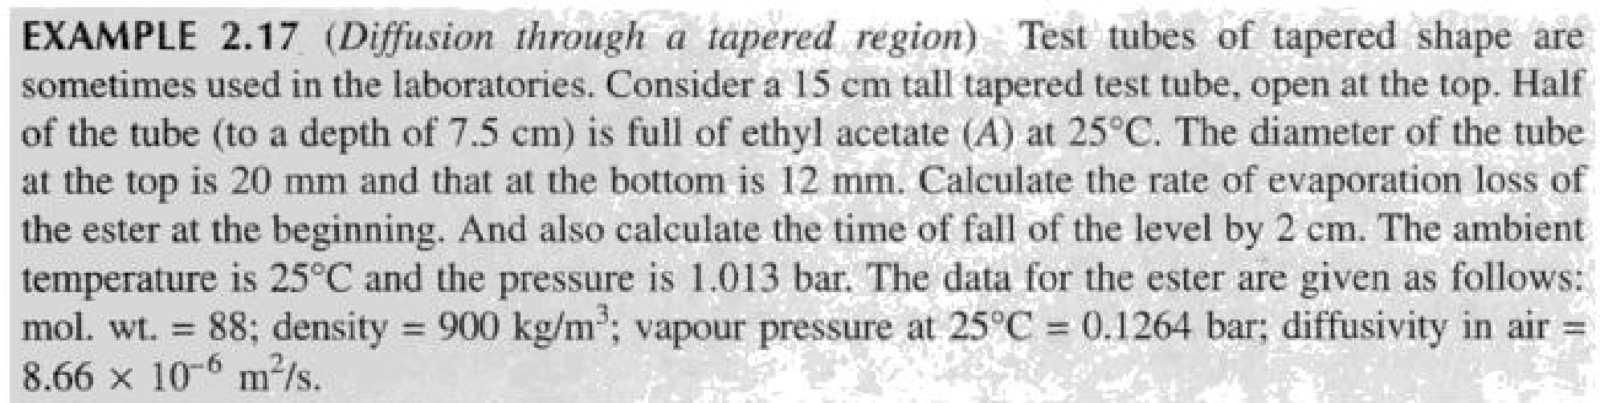

**Ex.2.14 page no.51**

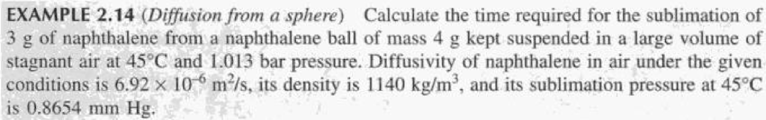

**Ex.2.15 Page no.51**

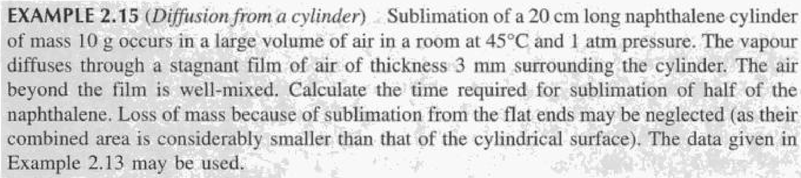

**Section=2**

(Unsolved problems)

1. The composition of air is often given in terms of only the two principal species in the gas mixture

oxygen, O2, yo2 = 0:21

nitrogen, N2, yN2 = 0:79

Determine the mass fraction of both oxygen and nitrogen and the mean molecular weight of the air when it is maintained at 250C (298 K) and 1 atm (1.013×105 Pa). The molecular weight of oxygen is 0.032 kg/mol and of nitrogen is 0.028 kg/mol.

1. Evaluate the diffusion coefficient of carbon dioxide in air at 200C and atmospheric pressure. ΩD = 1.047

The values of s and e/k are,

Ϭ in A0 εA, in K

Carbon dioxide 3.996 190

Air 3.617 97

1. In the chemical vapor deposition of silane (SiH4) on a silicon wafer, a process gas stream rich in an inert nitrogen (N2) carrier gas has the following composition:

ySIH4 = 0.0075, yH2 = 0.015, yN2 = 0.9775

The gas mixture is maintained at 900 K and 100 Pa total system pressure. Determine the diffusivity of silane through the gas mixture. The Lennard–Jones constants for silane are εA /k = 207.6K and ϬA = 4.08A0





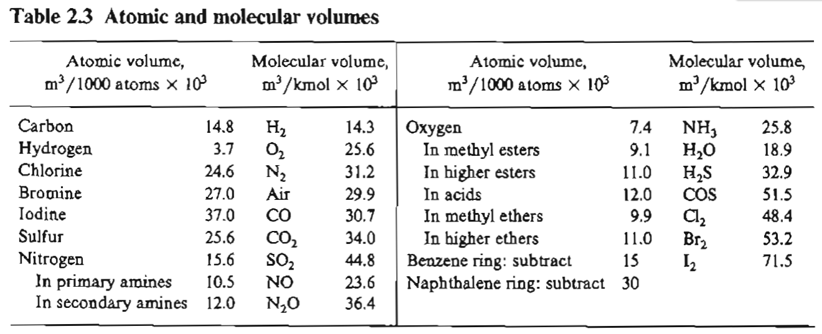

the remaining parameters to be used are

T = 283K

ΦB for water = 2.26, viscosity can be taken as that for water 0.001005 Kg/m.s And MB for water = 18

5) Estimate the liquid diffusivity of the following solutes that are transferred through dilute solution.

N-butanol in water at 288 K. VC4H9OH=103.6





**6)** The moisture in hot, humid, stagnant air surrounding a cold-water pipeline continually diffuses to the cold surface where it condenses. The condensed water forms a liquid film around the pipe, and then continuously drops off the pipe to the ground below. At a distance of 10cm from the surface of the pipe, the moisture content of the air is constant. Close to the pipe, the moisture content approaches the vapor pressure of water evaluated at the temperature of the pipe.

**a.** Draw a picture of the physical system, select the coordinate system that best describes the transfer process and state at least five reasonable assumptions of the mass-transfer aspects of the water condensation process.

**b.** What is the simplified form of the general differential equation for mass transfer in terms of the flux of water vapor, NA?

**c.** What is the simplified differential form of Fick’s equation for water vapor, NA?

**d.** What is the simplified form of the general differential equation for mass transfer in terms of the concentration of water vapor, CA?

**7)** Ethanol is diffusing through a 4-mm stagnant film of water. The ethanol concentrations of the entrance and the existing planes are maintained at 0.1 and 0:02 mol/m3, respectively. If the water film temperature is 283 K, determine the steady-state molar flux of the ethanol and the concentration profile as a function of the position z within the liquid film. Compare these results with a 4-mm stagnant film of air at 283 K and 1 atm at the same entrance and exit ethanol concentrations.

**8)** 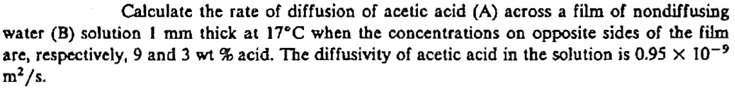

**9)** A tube 1 cm in inside diameter that is 20 cm long is filled with CO2 and H2 at a total pressure of 2 atm at 0C. The diffusion coefficient of the CO2 – H2 system under these conditions is 0.275cm2/sec. If the partial pressure of CO2 is 1.5 atm at one end of the tube and 0.5 atm at the other end, find the rate of diffusion for:

1. steady state equimolar counter diffusion (N A = - N B)
2. steady state counter diffusion where N B = -0.75 N A, and
3. steady state diffusion of CO2 through stagnant H2 (NB = 0)

**10)** A sphere of naphthalene having a radius of 2mm is suspended in a large volume of shell air at 318 K and 1 atm. The surface pressure of the naphthalene can be assumed to be at 318 K is 0.555 mm Hg. The D AB of naphthalene in air at 318 K is 6.92 * 10 –6m 2/sec. Calculate the rate of evaporation of naphthalene from the surface.

**11)**